# Design Overview for Food Terminator

Name: Nguyen Manh Dung

Student ID: 104181789

# Summary of Program

Food Terminator is a 2D moving getting food funny games where the player controls a character and eating foods. The objective is to eat as much food as you can and get a high score with only 3 lives. Player will meet 4 objects which is: Food(burger), Energy(Drink), Donut(Donut) and Bomb(Bomb), each objects have its own role whenever collide player.

Collide Food: Player gain 10 points

Collide Energy: Player gain back 1 life

Collide Donut: Player gain 100 points

Collide Bomb: Player lost 1 life

To make game harder, whenever player reach 80 points, all object speed be increase. A high score will save until you turn off game windows.

Sketch:

# Required Roles

Describe each of the classes, interfaces, and any enumerations you will create. Use a different table to describe each role you will have, using the following table templates.

Table : <<role name>> details – duplicate

|  |  |  |
| --- | --- | --- |
| Responsibility | Type Details | Notes |
| Decreases lives | Interger | Decrease player’s lives |
| Collisions with objects | Boolean | Collide with food and bomb |
| Increase lives | Interger | Increase player’s lives |
| Track score | Interger | Track player’s score |
| Move character | Sprite X,Y | Move ship using sprite X,Y |

Table : <<enumeration name>> details

|  |  |
| --- | --- |
| Value | Notes |
|  |  |

# Class Diagram

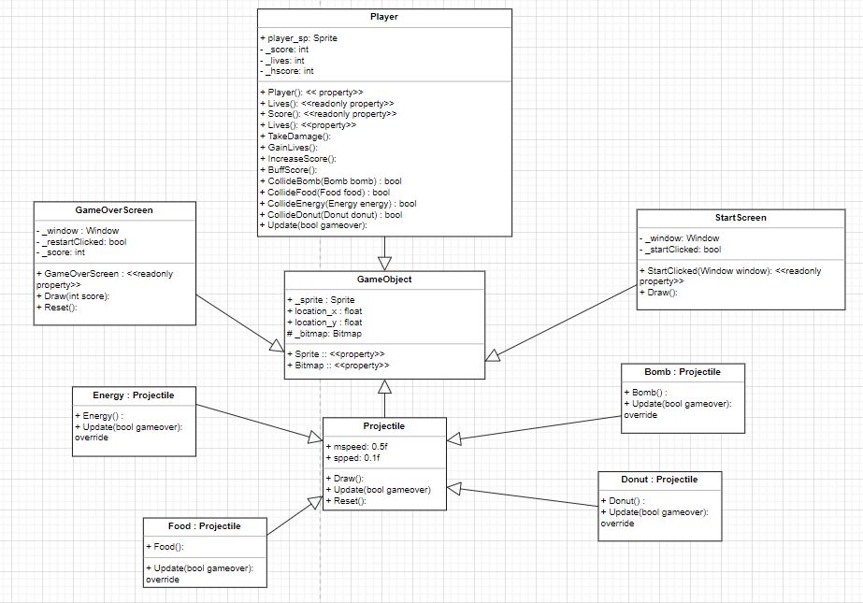

# Sequence Diagram

